Nama : Frederico Steven Kwok
NPM : 242310037
Kelas : TI-24-PA1
Mata Kuliah : Lab. Pemrograman Perangkat Bergerak
Tugas : Quiz 3
Github : https://github.com/RicoSteven120206/Aplikasi-Kantin-Kampus-Mobile.git
Penjelasan Dokumentasi
CampusBites adalah aplikasi kantin berbasis mobile yang dirancang untuk mempermudah mahasiswa dalam memesan makanan secara digital, memantau riwayat pesanan, dan melakukan transaksi secara cashless di lingkungan kampus.
Fitur utama dalam aplikasi Campus Bites
- Authentication: Sistem login dengan validasi user.
- Menu Explorer: Katalog makanan yang dapat difilter berdasarkan kategori dan dicari menggunakan fitur search.
- Cart Management: Penambahan/pengurangan jumlah item pesanan yang dikelola dengan Context API.
- Checkout & History: Proses checkout pesanan yang otomatis menyimpan riwayat pembelian.
- Dynamic Navigation: Navigasi berbasis Tab dengan integrasi Expo Router.
Menggunakan Tailwindcss yaitu dengan menggunakan Nativewind sebagai styling
Berikut Source Code Lengkap pada pengerjaan Quiz 3
Source Code pada app/index.jsx
import { AntDesign, FontAwesome5, Ionicons, MaterialIcons } from "@expo/vector-icons";
import { useRouter } from 'expo-router';
import { useState } from "react";
import {
ActivityIndicator,
Alert,
SafeAreaView,
ScrollView,
Text,
TextInput,
TouchableOpacity,
View
} from "react-native";

export default function App() {
const router = useRouter();

const [email, setEmail] = useState("");
const [password, setPassword] = useState("");
const [loading, setLoading] = useState(false);
const [showPassword, setShowPassword] = useState(false);

const handleSignIn = async () => {
if (!email || !password) {
Alert.alert("Error", "Mohon isi username dan password.");
return;
}

setLoading(true);

setTimeout(() => {
if (email === "mor_2314" && password === "83r5^_") {
setLoading(false);
router.replace("/(tabs)/menu");
} else {
setLoading(false);
Alert.alert("Login Gagal", "Username atau Password salah. Silakan coba lagi.");
}
}, 1000);
};

return (
<SafeAreaView className="flex-1 bg-surface">
<ScrollView contentContainerStyle={{ flexGrow: 1 }} keyboardShouldPersistTaps="handled">
<View className="flex-1 items-center justify-center px-6 py-10 relative overflow-hidden">

<View className="absolute inset-0 -z-10 opacity-30 pointer-events-none">
<View className="absolute -top-[10%] -right-[10%] w-96 h-96 bg-primary-container rounded-full blur-[120px]" />
<View className="absolute -bottom-[10%] -left-[10%] w-80 h-80 bg-tertiary-container rounded-full blur-[100px]" />
</View>

<View className="w-full max-w-[400px]">
<View className="flex flex-col items-center mb-10 text-center">
<View className="mb-4 w-[64px] h-[64px] bg-primary-container rounded-xl flex items-center justify-center shadow-sm">
<MaterialIcons name="restaurant-menu" size={32} color="#705d00" />
</View>
<Text className="text-3xl font-bold text-on-surface mb-2">CampusBites</Text>
<Text className="text-base text-on-surface-variant text-center px-4">
Fueling your academic journey, one bite at a time.
</Text>
</View>

<View className="bg-surface-container-lowest rounded-xl p-6 border border-outline-variant shadow-sm mb-6">
<View className="gap-y-4">

<View>
<Text className="text-sm font-semibold mb-2">Email or Username</Text>
<View className="flex-row items-center h-12 px-4 bg-surface-container-low border border-outline-variant rounded-lg">
<FontAwesome5 name="user" size={16} color="#7e775f" />
<TextInput
className="flex-1 ml-3 text-base text-on-surface"
placeholder="e.g. mor_2314"
placeholderTextColor="#7e775f"
autoCapitalize="none"
value={email}
onChangeText={setEmail}
/>
</View>
</View>

<View>
<View className="flex-row justify-between mb-2">
<Text className="text-sm font-semibold">Password</Text>
<TouchableOpacity>
<Text className="text-sm text-secondary">Forgot Password?</Text>
</TouchableOpacity>
</View>
<View className="flex-row items-center h-12 px-4 bg-surface-container-low border border-outline-variant rounded-lg">
<FontAwesome5 name="lock" size={16} color="#7e775f" />
<TextInput
className="flex-1 ml-3 text-base text-on-surface"
placeholder="••••••••"
placeholderTextColor="#7e775f"
secureTextEntry={!showPassword}
value={password}
onChangeText={setPassword}
/>
<TouchableOpacity onPress={() => setShowPassword(!showPassword)}>
<Ionicons name={showPassword ? "eye-off-outline" : "eye-outline"} size={20} color="#7e775f" />
</TouchableOpacity>
</View>
</View>

<TouchableOpacity
onPress={handleSignIn}
disabled={loading}
className="mt-2 h-12 bg-primary-container rounded-lg flex items-center justify-center">
{loading ? (
<ActivityIndicator color="#705d00" />
) : (
<Text className="font-bold text-on-primary-fixed">Sign In</Text>
)}
</TouchableOpacity>

<View className="flex-row items-center my-2">
<View className="flex-1 h-[1px] bg-outline-variant" />
<Text className="mx-4 text-xs text-outline">OR</Text>
<View className="flex-1 h-[1px] bg-outline-variant" />
</View>

<TouchableOpacity className="h-12 bg-surface-container-lowest border border-outline-variant rounded-lg flex-row items-center justify-center">
<AntDesign name="google" size={20} color="#191c1d" />
<Text className="ml-3 font-semibold text-on-surface">Continue with Google</Text>
</TouchableOpacity>

</View>
</View>

<View className="bg-surface-container-high py-4 px-6 rounded-lg items-center mb-10">
<Text className="text-sm text-on-surface-variant text-center italic">
Note: Use <Text className="font-bold">mor_2314</Text> and <Text className="font-bold">83r5^_</Text> for testing.
</Text>
</View>

<Text className="text-xs text-outline text-center">© 2026 CampusBites. All rights reserved.</Text>
</View>
</View>
</ScrollView>
</SafeAreaView>
);
}
Source Code pada app/_layout.jsx
import { Stack } from 'expo-router';
import { CartProvider } from '../contexts/CartContext';
import './global.css';

export default function RootLayout() {
return (
<CartProvider>
<Stack screenOptions={{ headerShown: false }}>
<Stack.Screen name='index' />
<Stack.Screen name="(tabs)" />
</Stack>
</CartProvider>
);
}

Source Code pada app/(tabs)/_layout.jsx
import { Feather, MaterialCommunityIcons } from '@expo/vector-icons';
import { Tabs } from 'expo-router';
import { Text, View } from 'react-native';
import '../global.css';

export default function TabLayout() {
return (
<Tabs
screenOptions={{
headerShown: false,
tabBarStyle: {
backgroundColor: '#f1f0e8',
borderTopWidth: 1,
borderTopColor: '#e0e2db',
height: 85,
paddingTop: 10,
},
tabBarShowLabel: false,
}}
>
<Tabs.Screen
name="menu"
options={{
title: 'Menu',
tabBarIcon: ({ color, focused }) => (
<TabIcon
focused={focused}
color={color}
icon="silverware-fork-knife"
label="Menu"
IconComponent={MaterialCommunityIcons}
/>
),
}}
/>
<Tabs.Screen
name="cart"
options={{
title: 'Cart',
tabBarIcon: ({ color, focused }) => (
<TabIcon
focused={focused}
color={color}
icon="shopping-cart"
label="Cart"
IconComponent={Feather}
/>
),
}}
/>
<Tabs.Screen
name="history"
options={{
title: 'History',
tabBarIcon: ({ color, focused }) => (
<TabIcon
focused={focused}
color={color}
icon="history"
label="History"
IconComponent={MaterialCommunityIcons}
/>
),
}}
/>
</Tabs>
);
}

function TabIcon({ focused, color, icon, label, IconComponent }) {
return (
<View className="items-center justify-center w-24">
<View className={focused ? "bg-primary-container px-5 py-1 rounded-full items-center" : "items-center"}>
<IconComponent name={icon} size={22} color={focused ? '#705d00' : color} />
<Text className={`font-label-sm mt-0.5 ${focused ? 'text-on-primary-container font-bold' : 'text-outline'}`}>
{label}
</Text>
</View>
</View>
);
}
Source Code pada app/(tabs)/menu.jsx
import {
Feather,
MaterialCommunityIcons
} from "@expo/vector-icons";
import { useRouter } from "expo-router";
import { useContext, useMemo, useState } from "react";
import {
Image,
ScrollView,
Text,
TextInput,
TouchableOpacity,
View
} from "react-native";
import { SafeAreaView } from 'react-native-safe-area-context';
import { CartContext, PRODUCTS } from "../../contexts/CartContext";

const CATEGORIES = [
{ id: "all", name: "All", icon: "food-fork-drink" },
{ id: 1, name: "Rice", icon: "rice" },
{ id: 2, name: "Snacks", icon: "food-croissant" },
{ id: 3, name: "Drinks", icon: "cup-water" },
{ id: 4, name: "Noodles", icon: "noodles" },
];

const formatRupiah = (number) => {
return new Intl.NumberFormat("id-ID", {
style: "currency",
currency: "IDR",
minimumFractionDigits: 0
}).format(number);
};

export default function MenuScreen() {
const router = useRouter();
const [activeCategory, setActiveCategory] = useState("all");
const [searchQuery, setSearchQuery] = useState("");
const { cart, handleAdd, handleMinus, totalItems, totalPrice } = useContext(CartContext);
const filteredProducts = useMemo(() => {
let data = activeCategory === "all"
? PRODUCTS
: PRODUCTS.filter(product => product.categoryId === activeCategory);

if (searchQuery.trim() !== "") {
data = data.filter(product =>
product.name.toLowerCase().includes(searchQuery.toLowerCase())
);
}
return data;
}, [activeCategory, searchQuery]);

return (
<SafeAreaView className="flex-1 bg-surface">
<ScrollView
contentContainerStyle={{ paddingBottom: 120 }}
showsVerticalScrollIndicator={false}
>
<View className="px-container-margin pt-md">

<View className="flex-row justify-between items-center mb-lg">
<View className="flex-row items-center">
<Image
source={require('../../assets/images/anton jadi pns.png')}
className="w-10 h-10 rounded-full mr-sm"
/>
<View>
<Text className="font-headline-sm text-headline-sm text-on-surface">CampusBites</Text>
<Text className="font-label-sm text-label-sm text-outline">Kantin Gedung B</Text>
</View>
</View>
<TouchableOpacity className="relative p-2">
<Feather name="bell" size={20} color="#191c1d" />
</TouchableOpacity>
</View>

<View className="flex-row items-center bg-surface-container h-12 px-md rounded-xl mb-lg">
<Feather name="search" size={20} color="#7e775f" className="mr-sm" />
<TextInput
className="flex-1 font-body-md text-body-md text-on-surface"
placeholder="Craving for something specific?"
placeholderTextColor="#7e775f"
value={searchQuery}
onChangeText={setSearchQuery}
/>
</View>

<View className="mb-lg">
<Text className="font-headline-sm text-headline-sm text-on-surface mb-sm">Categories</Text>
<ScrollView horizontal showsHorizontalScrollIndicator={false}>
{CATEGORIES.map((cat) => {
const isActive = activeCategory === cat.id;
return (
<TouchableOpacity
key={cat.id}
onPress={() => setActiveCategory(cat.id)}
className={`flex-row items-center px-4 py-2 rounded-xl mr-sm border ${
isActive ? 'bg-primary-container border-primary-container' : 'bg-surface-container border-surface-variant'
}`}
>
<MaterialCommunityIcons name={cat.icon} size={16} color={isActive ? '#705d00' : '#4d4732'} className="mr-2" />
<Text className={`font-label-md ${isActive ? 'text-on-primary-container font-bold' : 'text-on-surface-variant'}`}>
{cat.name}
</Text>
</TouchableOpacity>
);
})}
</ScrollView>
</View>

<View className="mb-lg">
<Text className="font-headline-sm text-headline-sm text-on-surface mb-sm">Todays Selection</Text>

{filteredProducts.length === 0 ? (
<Text className="text-center text-outline my-xl">No items found.</Text>
) : (
<View className="flex-row flex-wrap justify-between">
{filteredProducts.map((product) => {
const qty = cart[product.id] || 0;
return (
<View key={product.id} className="w-[48%] bg-surface-container-lowest rounded-2xl p-sm shadow-sm mb-md border border-surface-variant">
<Image source={{ uri: product.image }} className="w-full h-32 rounded-xl mb-xs" />
<Text className="font-label-md text-on-surface mb-xs" numberOfLines={1}>{product.name}</Text>
<Text className="font-label-lg font-bold text-primary mb-sm">{formatRupiah(product.price)}</Text>

{qty > 0 ? (
<View className="flex-row items-center justify-between bg-primary-container py-1 px-2 rounded-lg">
<TouchableOpacity onPress={() => handleMinus(product.id)} className="p-1">
<Feather name="minus" size={16} color="#705d00" />
</TouchableOpacity>
<Text className="font-bold text-on-primary-container">{qty}</Text>
<TouchableOpacity onPress={() => handleAdd(product.id)} className="p-1">
<Feather name="plus" size={16} color="#705d00" />
</TouchableOpacity>
</View>
) : (
<TouchableOpacity onPress={() => handleAdd(product.id)} className="flex-row items-center justify-center bg-primary-container py-2 rounded-lg">
<Feather name="shopping-cart" size={14} color="#705d00" className="mr-1" />
<Text className="font-label-md text-on-primary-container font-bold">Add</Text>
</TouchableOpacity>
)}
</View>
)
})}
</View>
)}
</View>
</View>
</ScrollView>

{totalItems > 0 && (
<TouchableOpacity onPress={() => router.push("/cart")} className="absolute bottom-[20px] right-4 bg-[#6f5100] flex-row items-center px-4 py-3 rounded-2xl shadow-lg z-50">
<View className="relative mr-sm">
<Feather name="shopping-bag" size={20} color="#ffffff" />
<View className="absolute -top-2 -right-2 bg-error w-5 h-5 rounded-full items-center justify-center border border-white">
<Text className="text-[10px] font-bold text-white leading-tight">{totalItems}</Text>
</View>
</View>
<Text className="font-label-lg font-bold text-white ml-2">{formatRupiah(totalPrice)}</Text>
</TouchableOpacity>
)}

</SafeAreaView>
);
}
Source Code pada app/(tabs)/cart.jsx
import { Feather, FontAwesome5, MaterialCommunityIcons } from "@expo/vector-icons";
import { useRouter } from "expo-router";
import { useContext, useState } from "react";
import {
Alert,
Image,
ScrollView,
Text,
TouchableOpacity,
View
} from "react-native";
import { SafeAreaView } from 'react-native-safe-area-context';
import { CartContext } from "../../contexts/CartContext";

const PAYMENT_METHODS = [
{ id: "credits", name: "Campus Credits", icon: "wallet" },
{ id: "cash", name: "Cash", icon: "money-bill-wave" }
];

const formatRupiah = (number) => {
return new Intl.NumberFormat("id-ID", {
style: "currency",
currency: "IDR",
minimumFractionDigits: 0
}).format(number);
};

export default function CartScreen() {
const router = useRouter();
const [selectedPayment, setSelectedPayment] = useState("credits");

const { cartItemsArray, handleAdd, handleMinus, totalPrice, addOrderToHistory } = useContext(CartContext);

const tax = totalPrice * 0.10;
const delivery = 0; // FREE
const finalTotal = totalPrice + tax + delivery;

const handleCheckout = () => {
if (cartItemsArray.length === 0) return Alert.alert("Kosong", "Keranjang Anda kosong!");

Alert.alert(
"Order Placed!",
"Pesanan Anda berhasil dibuat dan disimpan di riwayat.",
[{
text: "OK",
onPress: () => {
addOrderToHistory(finalTotal);
router.replace("/history");
}
}]
);
};

return (
<SafeAreaView className="flex-1 bg-surface">
<ScrollView contentContainerStyle={{ paddingBottom: 100 }} showsVerticalScrollIndicator={false}>
<View className="px-container-margin pt-md">

<View className="flex-row justify-between items-center mb-xl">
<View className="flex-row items-center">
<Image
source={require('../../assets/images/anton jadi pns.png')}
className="w-10 h-10 rounded-full mr-sm"
/>
<Text className="font-headline-sm text-headline-sm text-on-surface font-bold">
CampusBites
</Text>
</View>
<TouchableOpacity className="relative p-2">
<Feather name="bell" size={20} color="#191c1d" />
</TouchableOpacity>
</View>

<View className="mb-lg">
<Text className="font-display-lg text-[28px] font-bold text-on-surface mb-xs">
Your Order
</Text>
<Text className="font-body-md text-on-surface-variant">
Review your items and proceed to checkout.
</Text>
</View>

<View className="mb-lg">
{cartItemsArray.length === 0 ? (
<View className="py-xl items-center justify-center">
<MaterialCommunityIcons name="cart-off" size={64} color="#d0c6ab" className="mb-md" />
<Text className="font-body-lg text-outline">Keranjang Anda kosong.</Text>
<TouchableOpacity onPress={() => router.back()} className="mt-md">
<Text className="font-label-lg font-bold text-primary">Kembali ke Menu</Text>
</TouchableOpacity>
</View>
) : (
cartItemsArray.map((item) => (
<View key={item.id} className="bg-surface-container-lowest border border-surface-variant rounded-2xl p-sm flex-row items-center mb-md shadow-sm">
<Image source={{ uri: item.image }} className="w-16 h-16 rounded-xl mr-md" />

<View className="flex-1 justify-center">
<View className="flex-row justify-between items-start mb-xs">
<View className="flex-1 pr-2">
<Text className="font-label-lg font-bold text-on-surface" numberOfLines={1}>{item.name}</Text>
<Text className="font-label-sm text-outline mt-1" numberOfLines={1}>{item.desc || "No description"}</Text>
</View>
<Text className="font-label-lg font-bold text-[#705d00]">
{formatRupiah(item.price)}
</Text>
</View>

<View className="flex-row items-center mt-1">
<TouchableOpacity
onPress={() => handleMinus(item.id)}
className="w-7 h-7 rounded-full border border-outline-variant flex items-center justify-center bg-surface"
>
<Feather name="minus" size={14} color="#191c1d" />
</TouchableOpacity>
<Text className="mx-3 font-bold text-on-surface">{item.qty}</Text>
<TouchableOpacity
onPress={() => handleAdd(item.id)}
className="w-7 h-7 rounded-full flex items-center justify-center bg-primary-container"
>
<Feather name="plus" size={14} color="#705d00" />
</TouchableOpacity>
</View>
</View>
</View>
))
)}
</View>

{cartItemsArray.length > 0 && (
<>
<View className="bg-surface-container-lowest rounded-2xl p-md border border-surface-variant mb-lg shadow-sm">
<Text className="font-label-lg font-bold text-on-surface mb-md">Order Summary</Text>

<View className="h-[1px] w-full bg-surface-variant mb-md" />

<View className="flex-row justify-between mb-sm">
<Text className="font-body-md text-outline">Subtotal</Text>
<Text className="font-body-md text-on-surface">{formatRupiah(totalPrice)}</Text>
</View>
<View className="flex-row justify-between mb-sm">
<Text className="font-body-md text-outline">Tax (10%)</Text>
<Text className="font-body-md text-on-surface">{formatRupiah(tax)}</Text>
</View>
<View className="flex-row justify-between mb-md">
<Text className="font-body-md text-outline">Delivery Fee</Text>
<Text className="font-body-md font-bold text-[#1c6d24]">FREE</Text>
</View>

<View className="flex-row justify-between items-center mt-2">
<Text className="font-headline-sm font-bold text-on-surface">Total</Text>
<Text className="font-headline-sm font-bold text-[#705d00]">{formatRupiah(finalTotal)}</Text>
</View>
</View>

<View className="mb-lg">
<Text className="font-label-lg font-bold text-on-surface mb-sm">Payment Method</Text>
<ScrollView horizontal showsHorizontalScrollIndicator={false} className="py-1">
{PAYMENT_METHODS.map((method) => {
const isActive = selectedPayment === method.id;
return (
<TouchableOpacity
key={method.id}
onPress={() => setSelectedPayment(method.id)}
className={`flex-row items-center px-4 py-3 rounded-xl mr-3 border ${
isActive ? 'bg-primary-container border-primary-container' : 'bg-surface-container-lowest border-surface-variant'
}`}
>
<FontAwesome5
name={method.icon}
size={16}
color={isActive ? '#705d00' : '#4d4732'}
className="mr-2"
/>
<Text className={`font-label-md ${isActive ? 'text-on-primary-container font-bold' : 'text-on-surface-variant'}`}>
{method.name}
</Text>
</TouchableOpacity>
);
})}
</ScrollView>
</View>

<TouchableOpacity
onPress={handleCheckout}
className="w-full h-12 bg-[#ffd700] rounded-xl flex-row items-center justify-center shadow-sm mb-md"
>
<Text className="font-label-lg font-bold text-[#705d00] mr-2">Place Order</Text>
<Feather name="arrow-right" size={20} color="#705d00" />
</TouchableOpacity>
</>
)}

</View>
</ScrollView>

</SafeAreaView>
);
}

Source Code pada app/(tabs)/history.jsx
import { Feather, MaterialCommunityIcons } from "@expo/vector-icons";
import { useRouter } from "expo-router";
import { useContext, useState } from "react";
import {
Image,
ScrollView,
Text,
TouchableOpacity,
View
} from "react-native";
import { SafeAreaView } from 'react-native-safe-area-context';
import { CartContext } from "../../contexts/CartContext";

const formatRupiah = (number) => {
return new Intl.NumberFormat("id-ID", {
style: "currency",
currency: "IDR",
minimumFractionDigits: 0
}).format(number);
};

const FILTERS = ["All Orders", "Active", "Completed", "Cancelled"];

const MOCK_HISTORY = [
{
id: "CB-7910",
date: "Yesterday, 6:30 PM",
status: "Success",
total: 35000,
items: [
{ name: "Bento Chicken Teriyaki", qty: 1 },
{ name: "Fluffy Pancakes", qty: 1 }
]
},
{
id: "CB-7128",
date: "22 Oct, 12:05 PM",
status: "Success",
total: 25000,
items: [
{ name: "Nasi Campur Bali", qty: 1 }
]
}
];

export default function HistoryScreen() {
const router = useRouter();
const [activeFilter, setActiveFilter] = useState("All Orders");

const { orderHistory } = useContext(CartContext);

const combinedHistory = [...orderHistory, ...MOCK_HISTORY];

const renderItemString = (items) => {
return items.map(item => `x${item.qty} ${item.name}`).join(", ");
};

return (
<SafeAreaView className="flex-1 bg-surface">
<ScrollView contentContainerStyle={{ paddingBottom: 100 }} showsVerticalScrollIndicator={false}>
<View className="px-container-margin pt-md">

<View className="flex-row justify-between items-center mb-xl">
<View className="flex-row items-center">
<Image
source={require('../../assets/images/anton jadi pns.png')}
className="w-10 h-10 rounded-full mr-sm"
/>
<Text className="font-headline-sm text-headline-sm text-on-surface font-bold">
CampusBites
</Text>
</View>
<TouchableOpacity className="relative p-2">
<Feather name="bell" size={20} color="#191c1d" />
</TouchableOpacity>
</View>

<View className="mb-md">
<Text className="font-display-lg text-[28px] font-bold text-on-surface mb-xs">
Order History
</Text>
<Text className="font-body-md text-on-surface-variant">
Review your past meals and current status.
</Text>
</View>

<View className="mb-lg">
<ScrollView horizontal showsHorizontalScrollIndicator={false}>
{FILTERS.map((filter, index) => {
const isActive = activeFilter === filter;
return (
<TouchableOpacity
key={index}
onPress={() => setActiveFilter(filter)}
className={`px-5 py-2 rounded-full mr-3 ${
isActive ? 'bg-primary-container' : 'bg-surface-container-high'
}`}
>
<Text className={`font-label-md font-bold ${
isActive ? 'text-on-primary-container' : 'text-outline'
}`}>
{filter}
</Text>
</TouchableOpacity>
);
})}
</ScrollView>
</View>

<View className="mb-lg">
{combinedHistory.length === 0 ? (
<Text className="text-center text-outline my-xl">Belum ada riwayat pesanan.</Text>
) : (
combinedHistory.map((order, index) => {
const isPending = order.status === "Pending";
const cardBorderColor = isPending ? "border-l-[#ffd700]" : "border-l-[#88d982]"; // Kuning/Hijau

return (
<View
key={index}
className={`bg-surface-container-lowest rounded-2xl p-md shadow-sm mb-md border-y border-r border-surface-variant border-l-4 ${cardBorderColor}`}
>
<View className="flex-row justify-between items-start mb-sm">
<Text className="font-label-sm text-outline mt-1">
Order #{order.id} • {order.date}
</Text>

<View className={`px-2 py-1 rounded-md flex-row items-center ${
isPending ? 'bg-[#ffd700]/20' : 'bg-[#88d982]/20'
}`}>
{isPending ? (
<MaterialCommunityIcons name="clock-outline" size={12} color="#705d00" className="mr-1" />
) : (
<MaterialCommunityIcons name="check-circle-outline" size={12} color="#1b6d24" className="mr-1" />
)}
<Text className={`text-[10px] font-bold ${isPending ? 'text-[#705d00]' : 'text-[#1b6d24]'}`}>
{order.status}
</Text>
</View>
</View>

<Text className="font-headline-sm font-bold text-on-surface mb-xs">
{order.items[0]?.name} {order.items.length > 1 ? `+${order.items.length - 1} lainnya` : ''}
</Text>
<Text className="font-body-md text-outline mb-md" numberOfLines={2}>
{renderItemString(order.items)}
</Text>

<View className="flex-row justify-between items-center mt-1">
<Text className="font-headline-sm font-bold text-[#705d00]">
{formatRupiah(order.total)}
</Text>

{isPending ? (
<TouchableOpacity>
<Text className="font-label-md font-bold text-secondary underline">
Track Status
</Text>
</TouchableOpacity>
) : (
<TouchableOpacity className="bg-[#ffd700] px-4 py-1.5 rounded-full">
<Text className="font-label-md font-bold text-[#705d00]">Reorder</Text>
</TouchableOpacity>
)}
</View>
</View>
);
})
)}
</View>

</View>
</ScrollView>

<TouchableOpacity
className="absolute bottom-[20px] right-4 bg-[#705d00] w-14 h-14 rounded-full flex items-center justify-center shadow-lg z-50"
onPress={() => router.push("/menu")}
>
<Feather name="plus" size={24} color="#ffffff" />
</TouchableOpacity>

</SafeAreaView>
);
}

Dokumentasi Hasil/Output dari pengerjaan
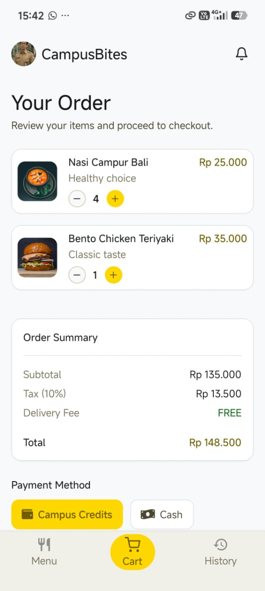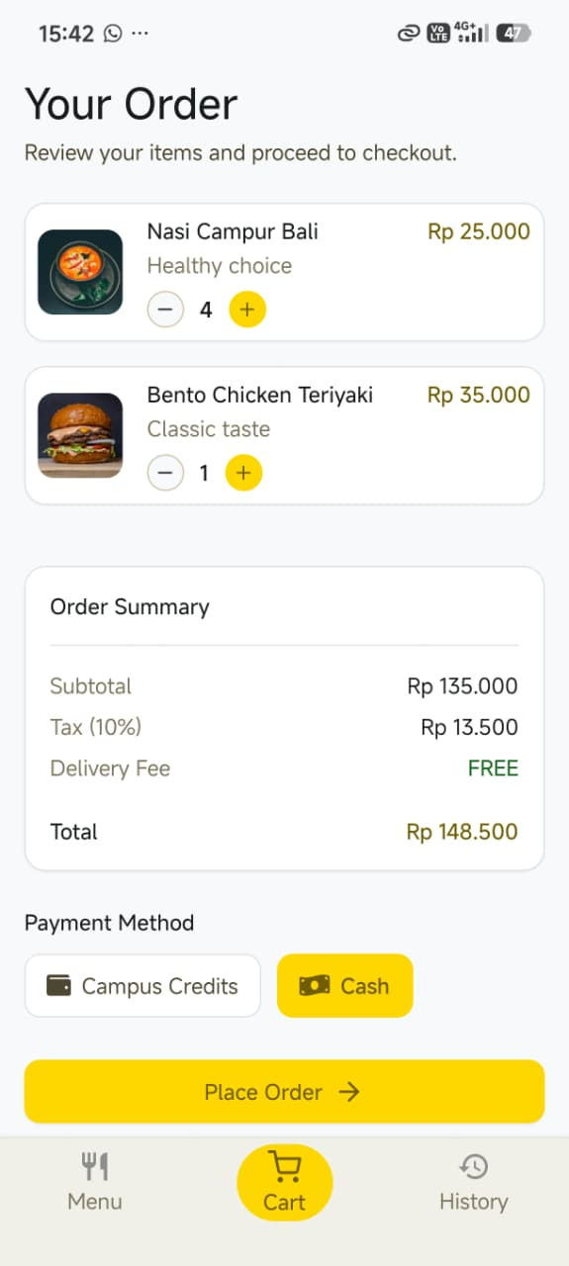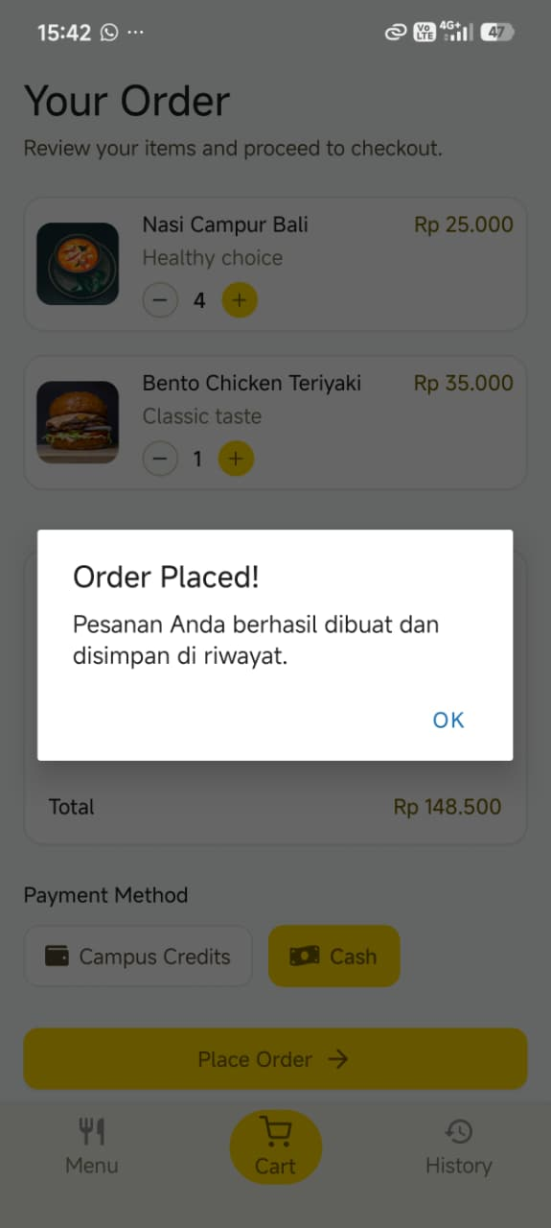
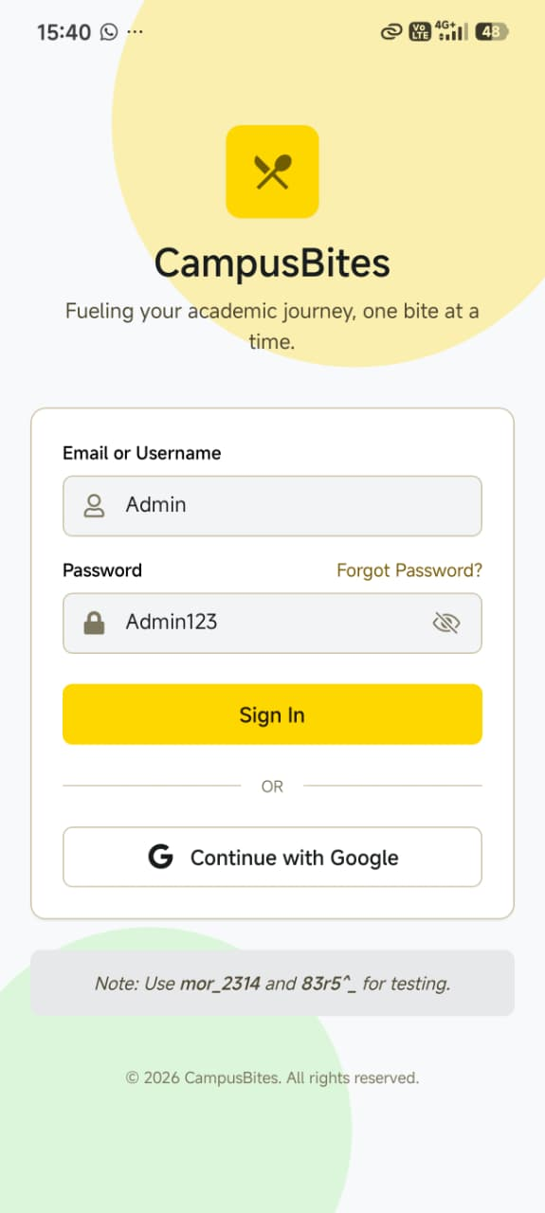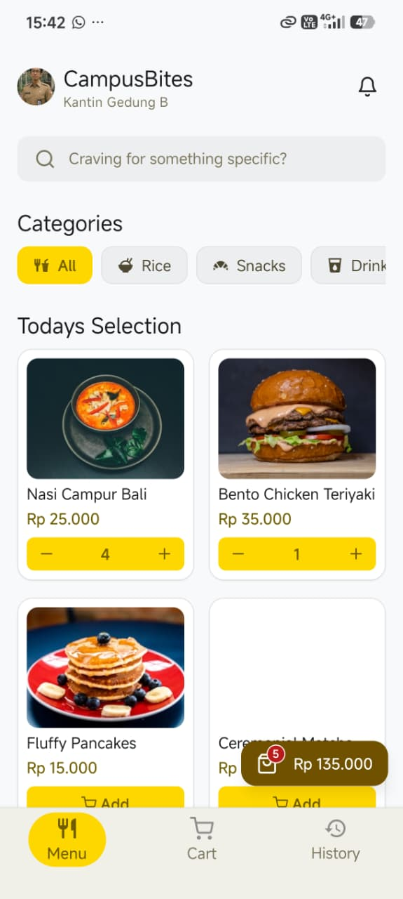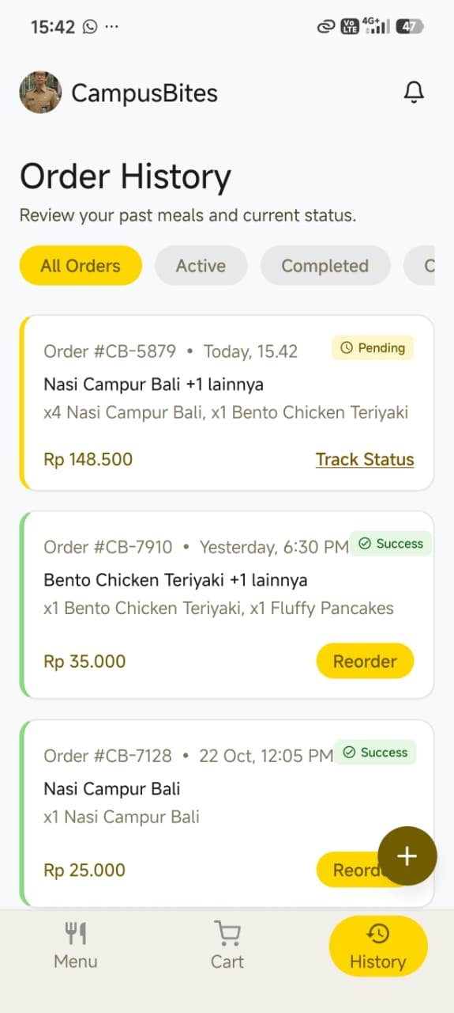
Upload project pada GITHUB yang telah dibuat yaitu "Aplikasi-Kantin-Kampus-Mobile", namun commit dengan nama "PPB Quiz-3 Pertemuan 11”
Link GITHUB Repository:
https://github.com/RicoSteven120206/Aplikasi-Kantin-Kampus-Mobile.git

